**Fanka Shundovska**

**IntelliJ – JAVA Homework 2**

In IntelliJ:

1. In the following text “The quick brown fox jumps over the lazy dog” replace the letter o with Capital letter through the text.

package com.edu.sedc;  
  
public class JavaHomework2 {  
 public static void main(String[] args) {  
  
 String text = "They decided to go on a road trip across the country and visit many places.";  
 text = text.replace('o', 'O');  
 System.*out*.println(text);

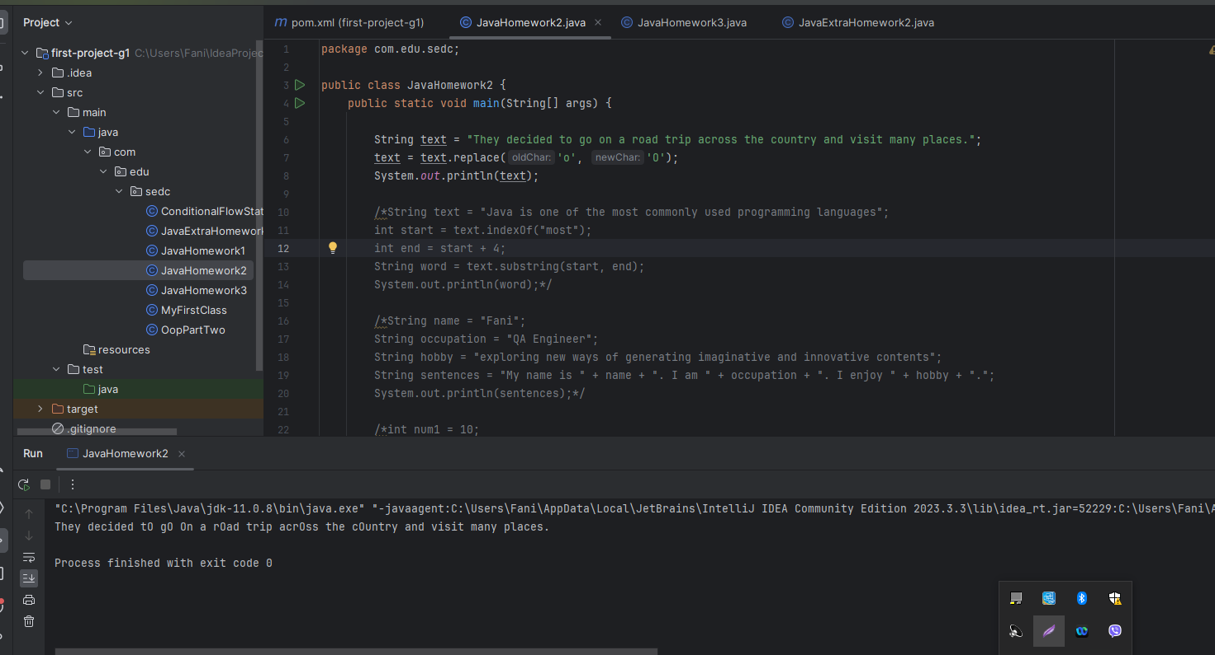

1. On the following text: Java is one of the most commonly used programming languages. Print only the word “most”.

String text = "Java is one of the most commonly used programming languages";  
int start = text.indexOf("most");  
int end = start + 4;  
String word = text.substring(start, end);  
System.*out*.println(word);

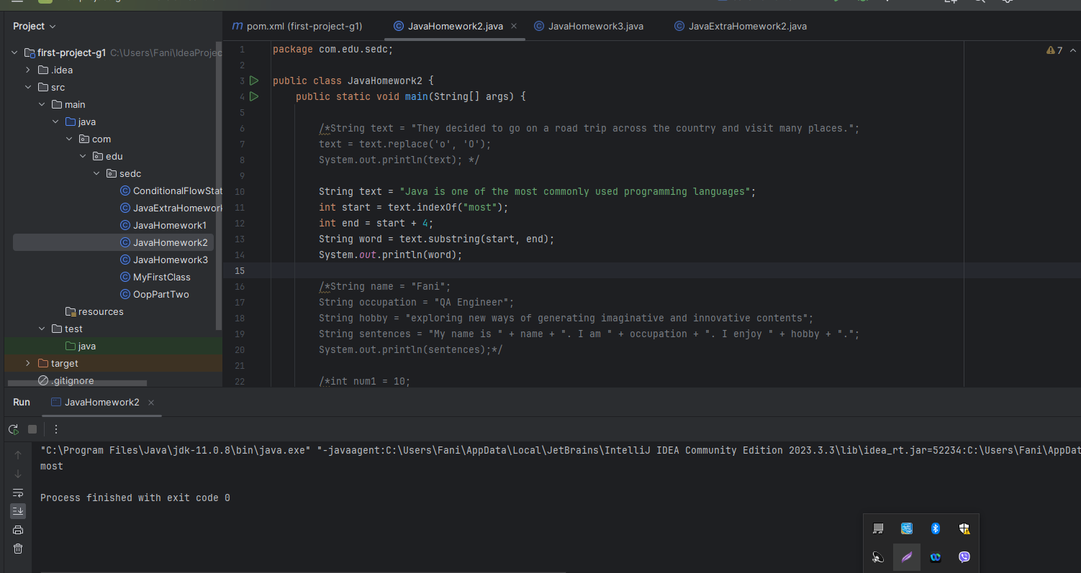

1. Write a few sentences about yourself by using concatenation and print them.

String name = "Fani";  
String occupation = "QA Engineer";  
String hobby = "exploring new ways of generating imaginative and innovative contents";  
String sentences = "My name is " + name + ". I am " + occupation + ". I enjoy " + hobby + ".";  
System.*out*.println(sentences);

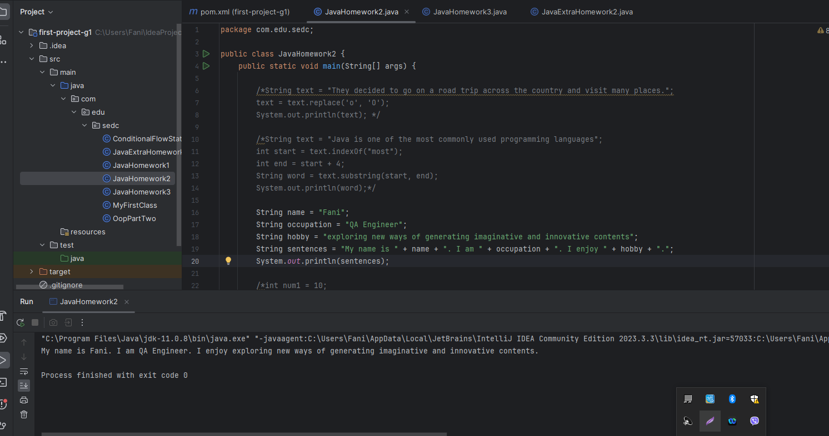

1. Create two variables of type int. Call the variables num1 and num2. Set an initial value on both variables.

* Create a third int variable, call it result and set its value equal to the sum of num1 and num2.
* Print the result.

int num1 = 10;  
int num2 = 5;  
int result = num1 + num2;  
System.*out*.println(result);

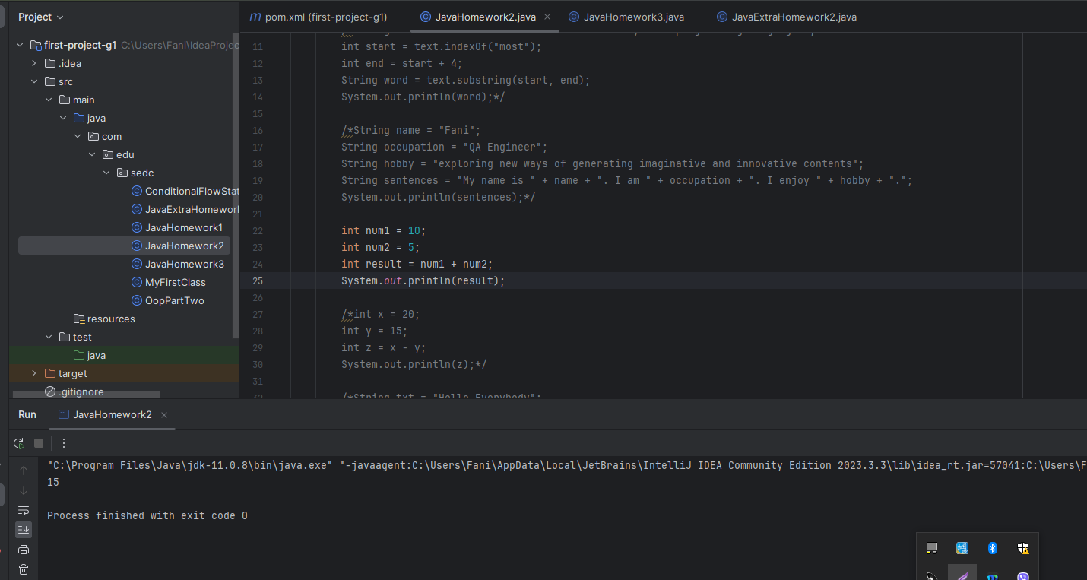

1. Set an initial value to variables called x and y. Create a variable called z, assign x - y to it, and display the result.

int x = 20;  
int y = 15;  
int z = x - y;  
System.*out*.println(z);

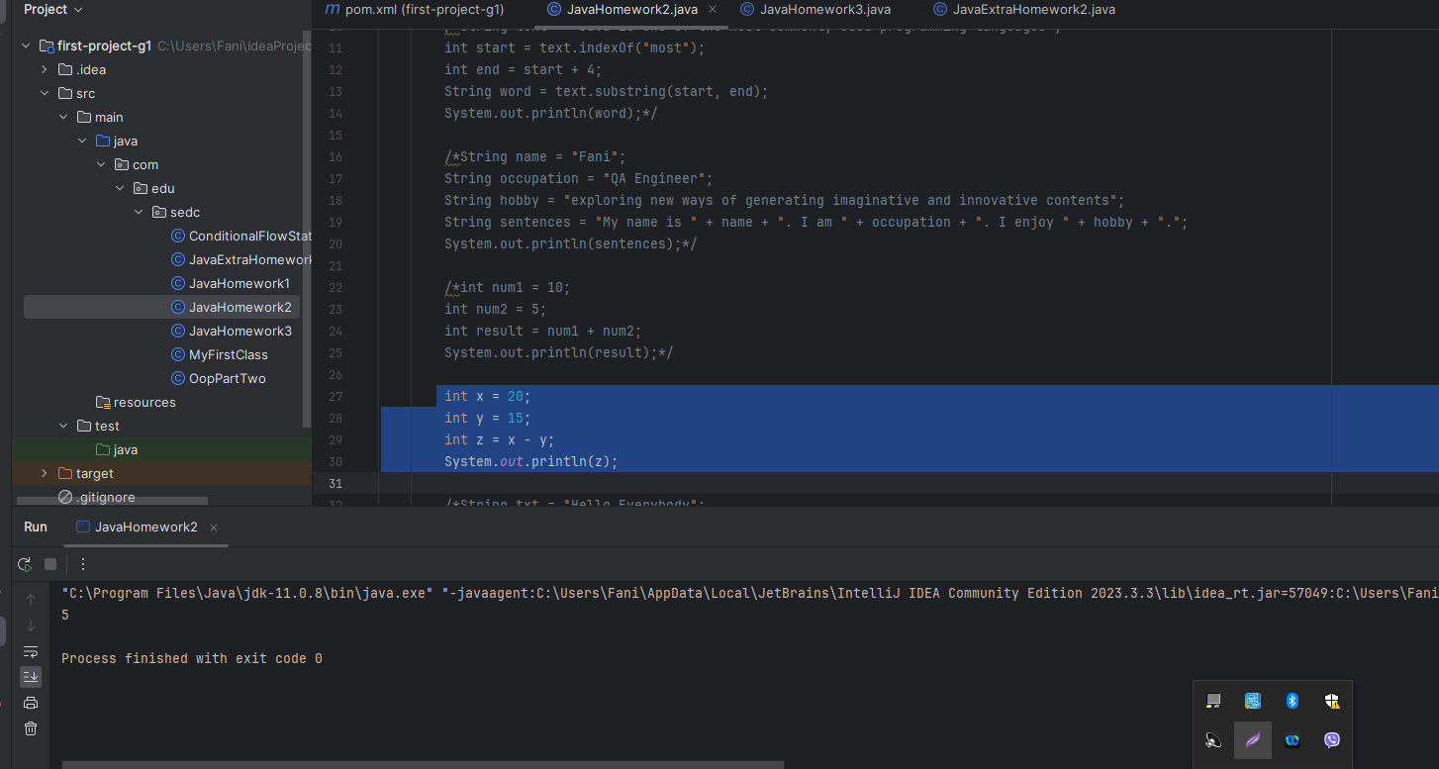

1. Return the index (position) of the first occurrence of "e" in the following string:

* String txt = "Hello Everybody";
* System.out.println(____________ );
* String txt = "Hello Everybody";  
  int index = txt.indexOf("e");  
  System.*out*.println(index);

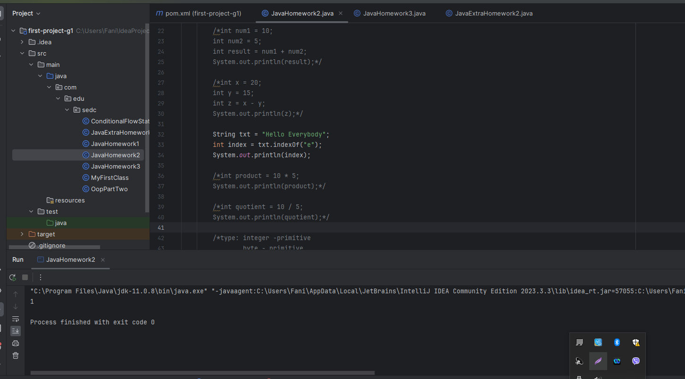

1. Multiply 10 with 5, and print the result.

int product = 10 * 5;  
System.*out*.println(product);

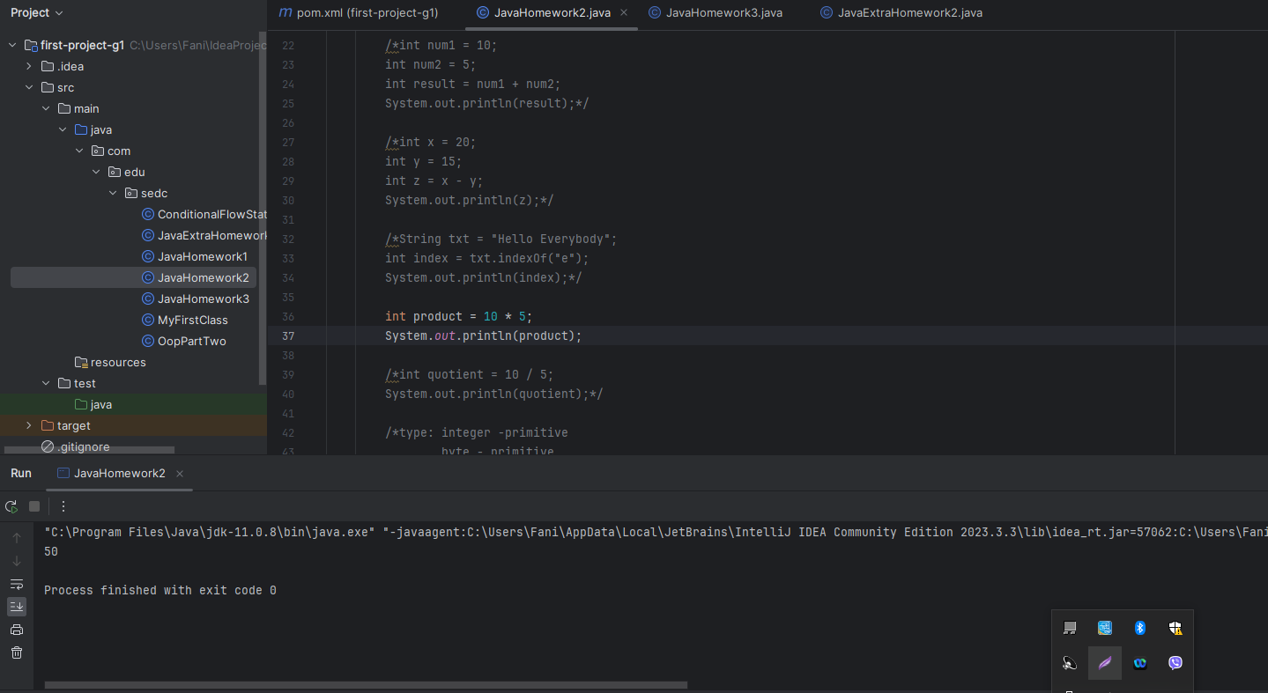

1. Divide 10 by 5, and print the result.

int quotient = 10 / 5;  
System.*out*.println(quotient);

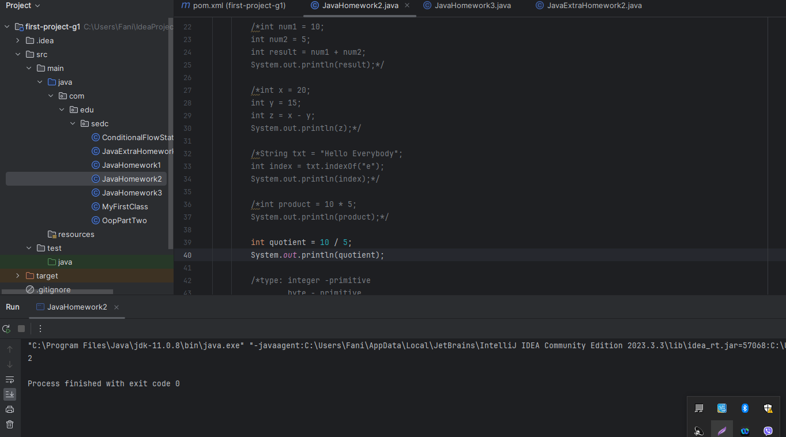

1. Which of the following types belongs to a group of primitive data type and which belongs to the group of non - primitive data type.

* integer, byte, float, double, string, array

type: integer -primitive  
 byte - primitive  
 float - primitive  
 double - primitive  
 string - non-primitive  
 array - non-primitive

